**CMPE-260 Laboratory Exercise 01**

**Implementation and Techniques**

By submitting this report, I attest that its contents are wholly my individual writing about this exercise and that they reflect the submitted code. I further acknowledge that permitted collaboration for this exercise consists only of discussions of concepts with course staff and fellow students; however, other than code provided by the instructor for this exercise, all code was developed by me.

John Judge

Performed 2/11/16

Submitted 2/18/16

Lab Section 04

Instructor: Dr. Lou Beato

TAs: Nick Barlow

Sergio Martins

Lecture Section 01

Professor: Dr. Reza Azarderakhsh

**Abstract**

In this exercise a digital comparator was constructed using VHDL programming techniques in combination with the Xilinx development program. The comparator was designed in VHDL mostly with given code. A testbench was designed to verify the correct functionality and then the design was simulated using the testbench and "real world" scenarios. Finally, the design was synthesized onto an FPGA. The exercise provided insight into the different styles of VHDL programming as well as the LUT approach in FPGAs. The exercise was a success, as the comparator worked as designed and behaved correctly when tested and synthesized.

**Design Methodology**

This exercise required the use of the Xilinx ISE development tools and the VHDL programming language. In order to begin the exercise a new projector it had to be created in the Xilinx IDE. Once the settings were correctly set for the Spartan 6 board that would later be used, the components of the comparator could be implemented. The combination of these components created the digital comparator.

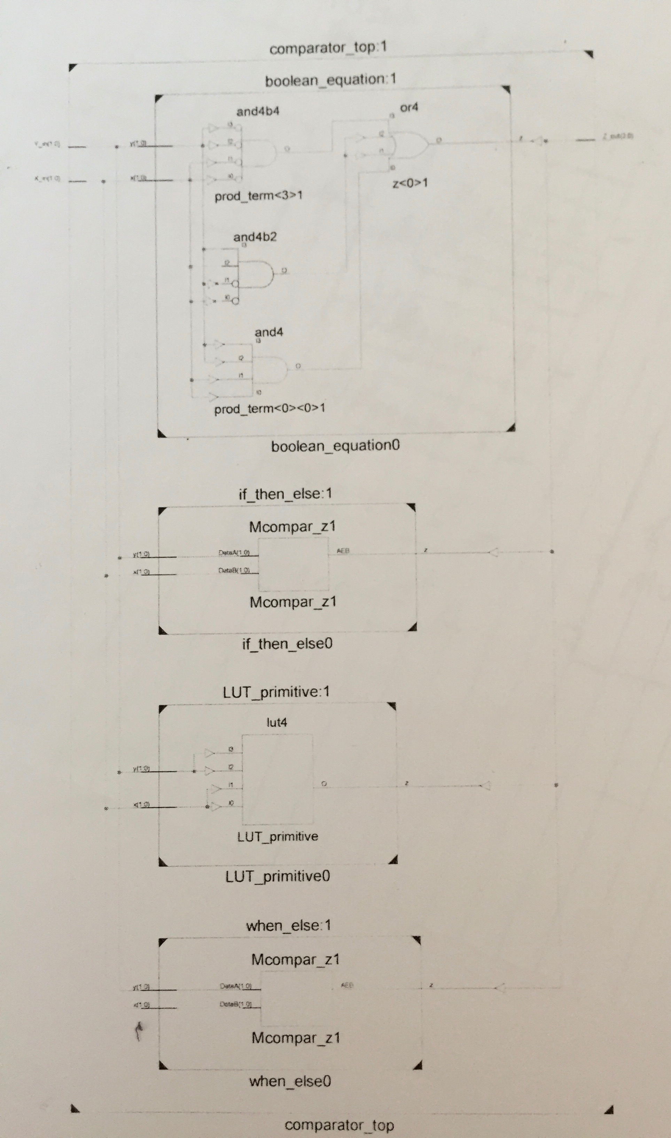

Figure (1.1): Top-Level Block Diagram of a Two-Bit Digital Comparator

As seen in Figure (1.1), the design incorporated five design units. These design units were; the If-Then-Else statement, the When-Else statement, the Boolean Equation, the Primitive LUT, and the Top-Level Wrapper (Figures (1.2), (1.3), (1.4), (1.5), and (1.6) respectively). All were added to the project by using the hierarchy window and adding a new source. For the entire design unit, the code was given, except the Primitive LUT. In order to implement the LUT, first, the INIT value of the LUT had to be determined using a truth table.

|  |  |  |  |  |  |
| --- | --- | --- | --- | --- | --- |
| X1 | X0 | Y1 | Y0 | Z | INIT |
| 0 | 0 | 0 | 0 | 1 | 8 |
| 0 | 0 | 0 | 1 | 0 |
| 0 | 0 | 1 | 0 | 0 |
| 0 | 0 | 1 | 1 | 0 |
| 0 | 1 | 0 | 0 | 0 | 4 |
| 0 | 1 | 0 | 1 | 1 |
| 0 | 1 | 1 | 0 | 0 |
| 0 | 1 | 1 | 1 | 0 |
| 1 | 0 | 0 | 0 | 0 | 2 |
| 1 | 0 | 0 | 1 | 0 |
| 1 | 0 | 1 | 0 | 1 |
| 1 | 0 | 1 | 1 | 0 |
| 1 | 1 | 0 | 0 | 0 | 1 |
| 1 | 1 | 0 | 1 | 0 |
| 1 | 1 | 1 | 0 | 0 |
| 1 | 1 | 1 | 1 | 1 |

Table (1.1): Primitive LUT truth table

The design of the primitive LUT can be seen in Table (1.1). Using the INIT value determined by the table, the VHDL code was found in the Xilinx library. In order to be correctly implemented, the code had to be modified to contain the right signals variables, which were used in other design units. Once the LUT was implemented, the testbench could be designed.

The testbench used a for loop to test the 16 possible combinations for the input variables. The code for this testbench was also provided and can be found in Figure (1.7). In order to confirm no unwanted changes were made in the copying and pasting of code, the syntax was checked using the IDE's built in debugger in the synthesis tools. Once the code was correctly implemented, the simulation could occur.

By following the steps provided at the beginning of the exercise the simulation took place and was verified to be correct by the waveform model generated. Even though the correct waveform was generated, for the purposes of this exercise, the testbench was modified to contain produce an incorrect waveform. This was done by removing one NOT operator and adding in an extra NOT operator in a different spot of the equation. These original waveform and the resulting incorrect waveform can be seen in Figures (1.8) and (1.9), respectively.

This verified the design of the comparator was correct and the project was ready to be synthesized. Synthesis is the process in which the software decides what logic gates is required in the design. By following the steps provided for synthesis the program synthesized the design. The resulting design of the if-then-else, when-else, and Boolean equation can be seen in Figure (2.0), which was captured following the synthesis.

Following synthesis, a post-route simulation took place. This is also known as a timing simulation because the process uses true timing delays information in the design. It is used to simulate the design after it has been routed to the FPGA. The resulting waveform, with correct timing delays, can be found in Figure (2.1).

Finally the comparator could be implemented on the FPGA. This was, once again, done using the Xilinx software. Once the comparator was programmed onto the board, the board was tested and verified to be correct by using different combinations of the input variables. These results were compared to the expected results from the first testbench.

**Results**

Once all of the design entities and the test bench were written the project could be tested. It was first tested using the test bench and exporting the project to ModelSim. From there, the Post-Route Simulation took place and the design was tested once more in ModelSim. It was after the Post-Route simulation that the design could be verified to be correct and was ready to be programmed onto the board.

*Test bench Results*

For this exercise, the test bench was given. Only entity and architecture names had to be changed. The test bench simulated the design by varying the inputs and systematically going through all of the 16 possible inputs. The resulting waveform, which can been seen in Figure (1.8), shows the result of simulation. As the simulation changed the input variables, the output changed simultaneously. Only when the two 2-bit inputs matched did the 4-bit output read “1111.” For all other nonmatching combinations of inputs the result was “0000.” This waveform was verified to be correct at the time of the exercise.

For the sake of the exercise, the test bench was then modified to produce an incorrect waveform. Then the project was simulated again in ModelSim and the resulting waveform was examined. The very noticeable difference between the waveforms in Figures (1.8) and (1.9) was annotated. Before the project moved on the test bench was changed back to the correct implementation and saved.

*Post-Route Simulation Results*

Following the initial simulation, the post-route simulation took place. The post-route simulation used the same test bench as before but minor changes were added in the code to add “real world” delays. These delays are essential because the more closely model hardware. The post-route simulation took place and the resulting waveform, as seen in Figure (1.9), looked identical to Figure (1.8) (The correct test bench results) except with the addition of delays on the outputs. The annotated results can be found in the appendix

*Hardware*

At this point in the exercise, the board was programmed with the project and after the I/O pins were correctly set up the final simulation could take place. With the board connected to a power source all that had to be done was to change the position of the switches on the board to simulate changing inputs. The result of the equation was shown by the LEDs in the board. A bright LED represented 1 and an off LED represented a 0. After testing different inputs the result matched the correct waveform from the post-route simulation and the exercise was then verified to be correct.

**Conclusion**

In this exercise, several VHDL programming techniques and the Xilinx development program were used. The exercise served to show as an example of how VHDL programs can be synthesized into hardware. The objectives of the exercise were met. The design, synthesis, simulation, and hardware implementation all resulted in correct results. This shows that the exercise was carried out correctly and can b e used as a stepping-stone for larger and more complex exercises in the future.

**Appendix**

Figure (1.1): Top-Level Block Diagram of a Two-Bit Digital Comparator



Figure (1.2): Block Diagram of If-Then-Else statement

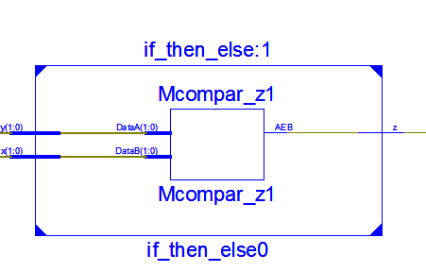

Figure (1.3): Block Diagram of When-Else statement

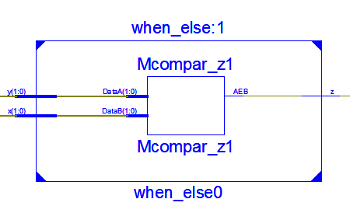

Figure (1.4): Block Diagram of Boolean Equation

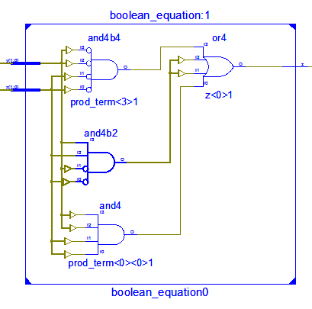

Figure (1.5): Block Diagram of Primitive LUT

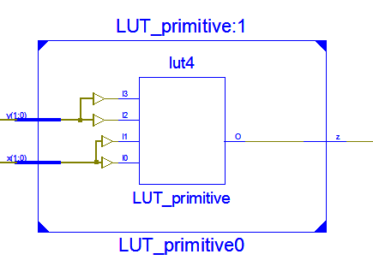

Figure (1.6): Block Diagram of Top-Level Wrapper



Figure (1.7): Test Bench

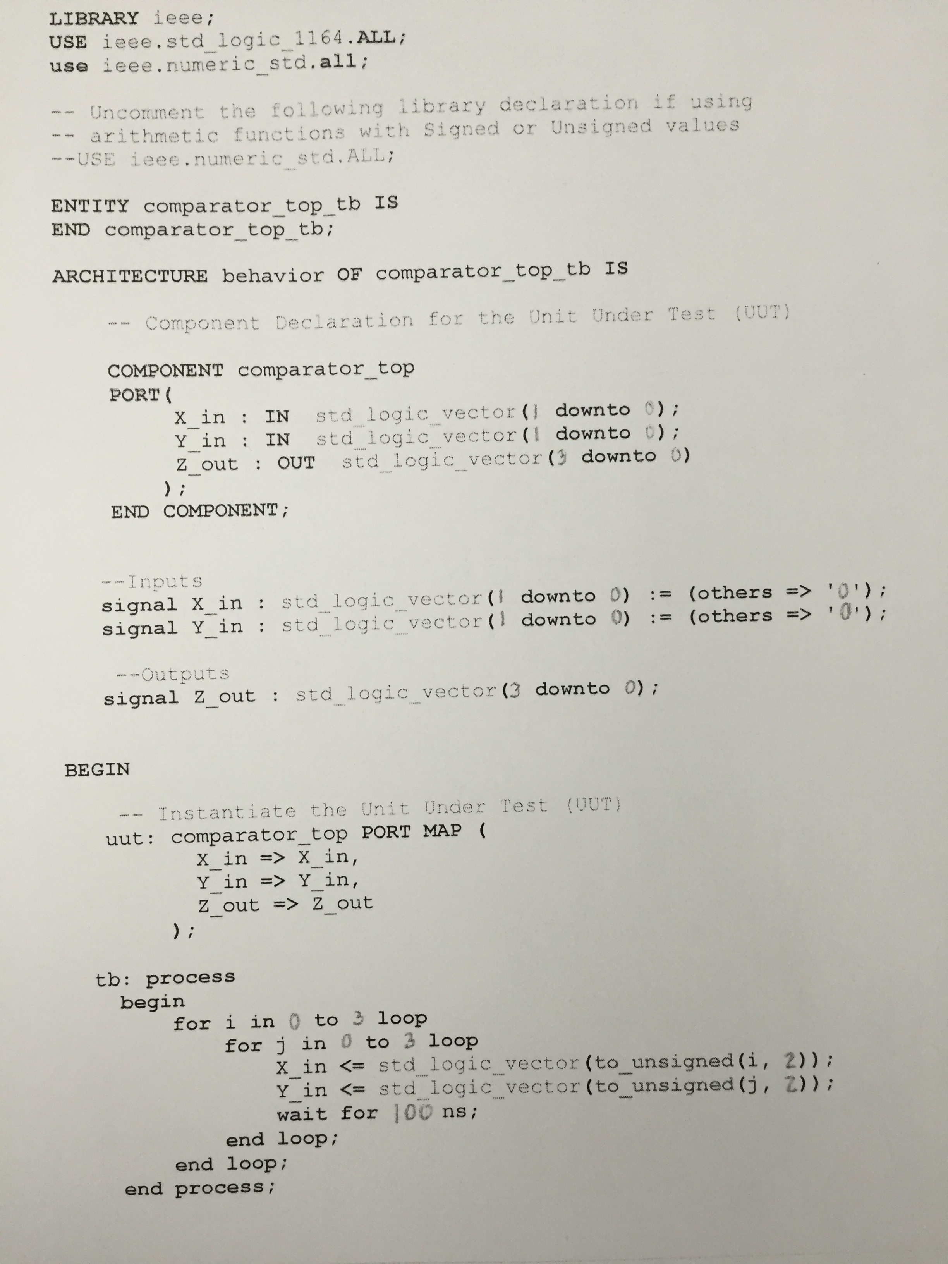

Figure (1.8): Waveform generated by correct test bench

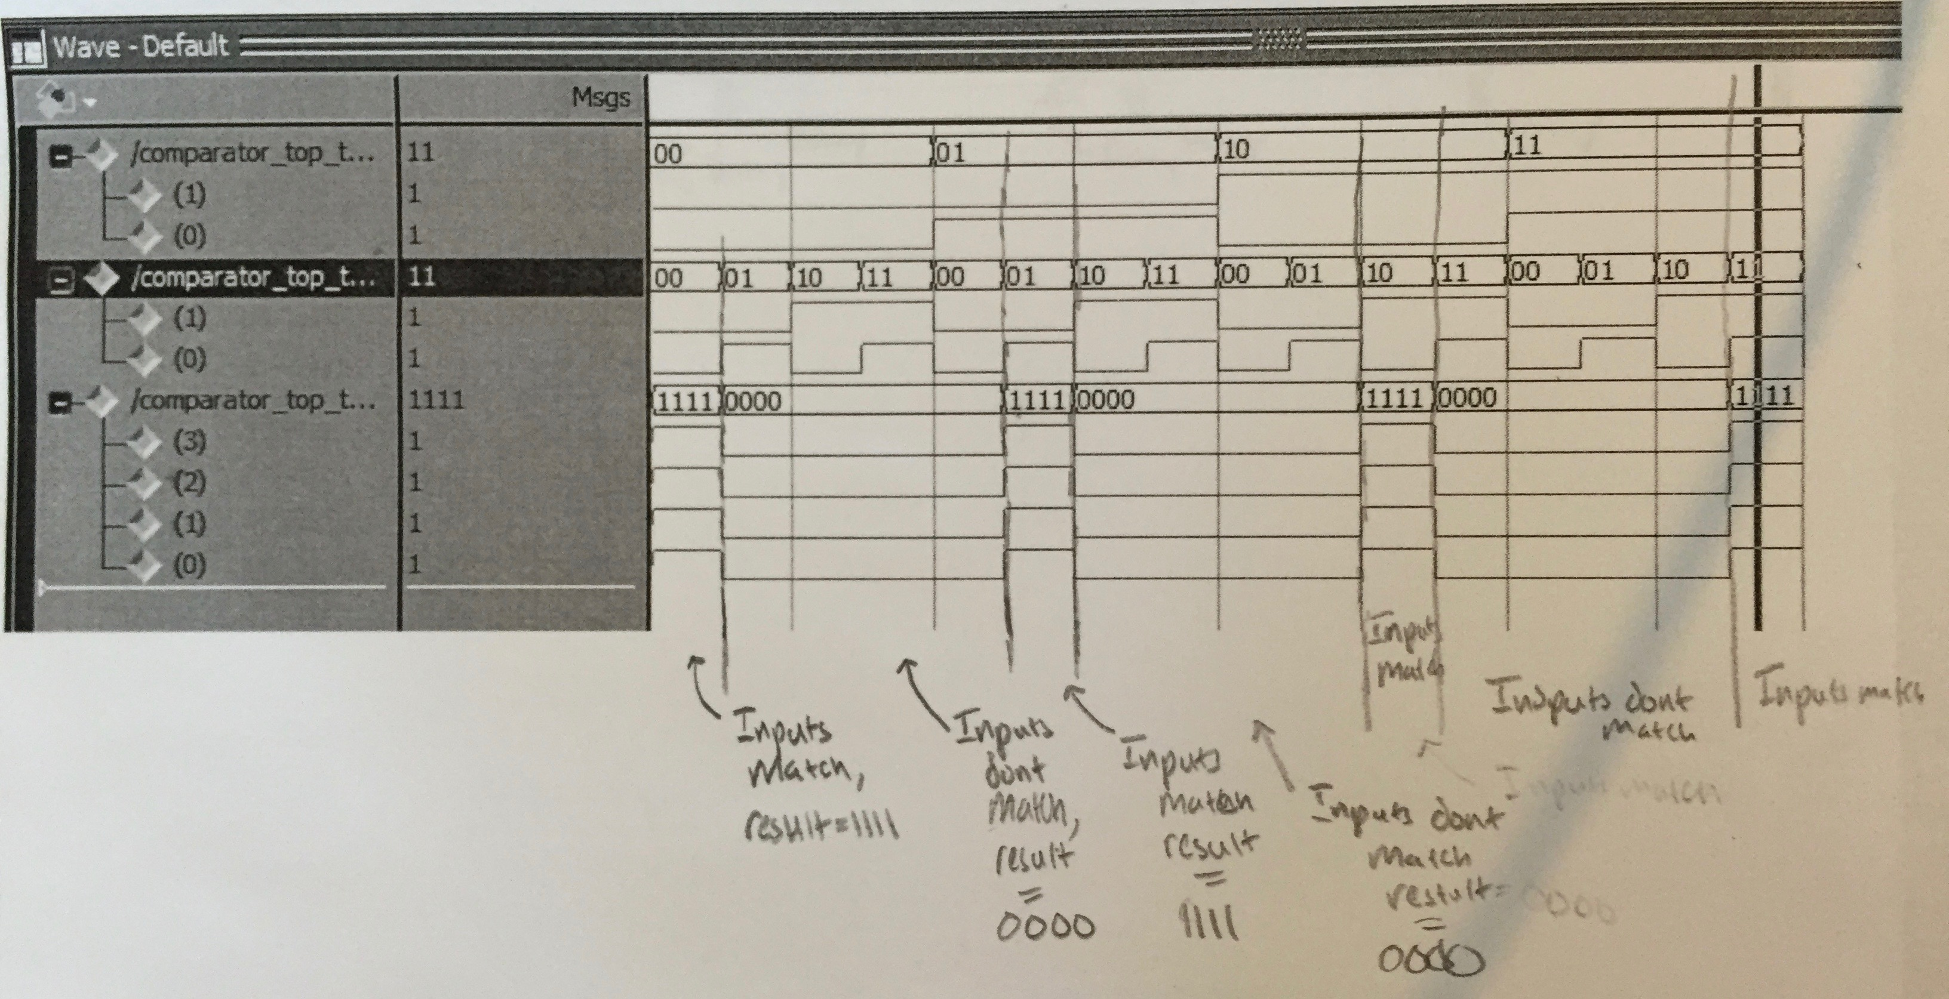

Figure (1.9): Waveform generated by incorrect test bench

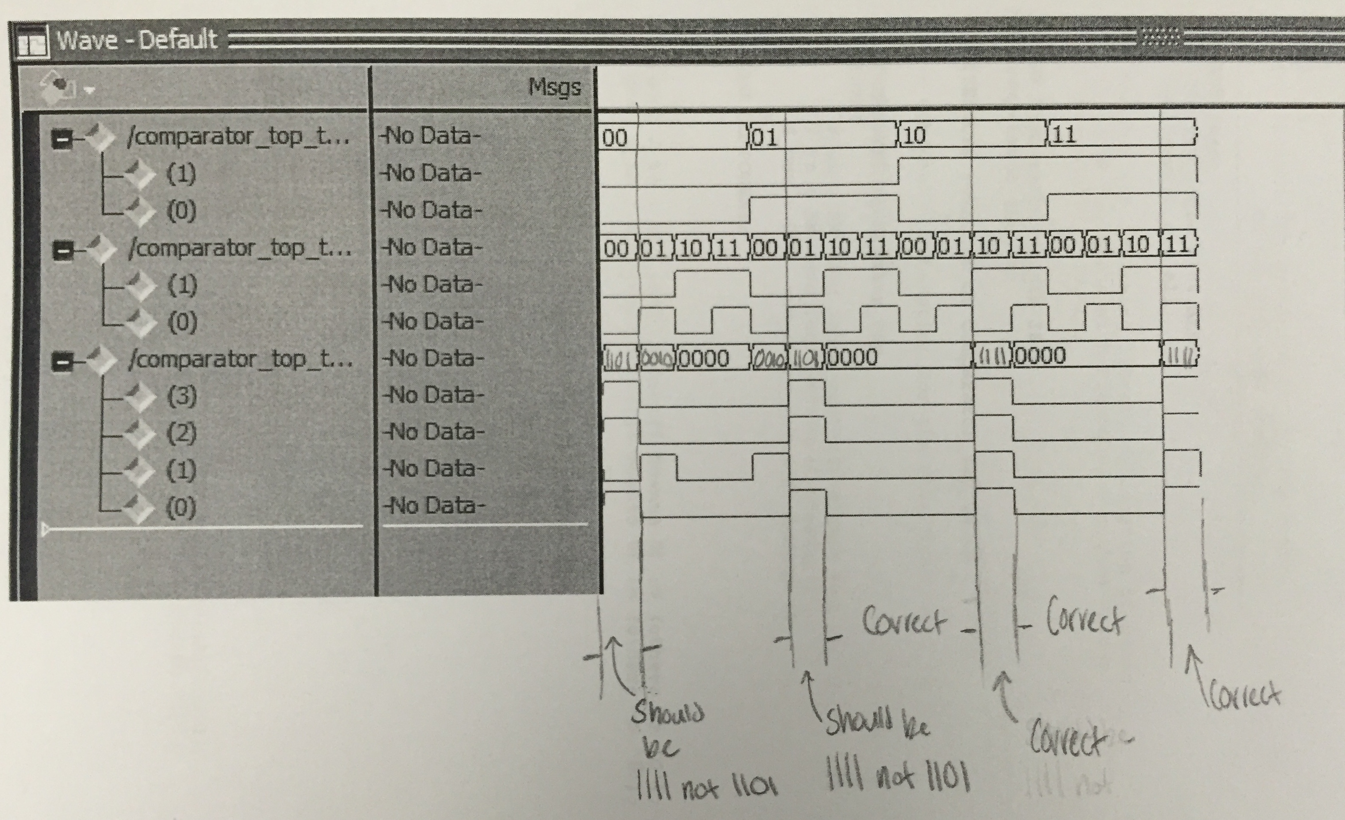

Figure (2.0): Synthesized Diagram of Project



Figure (2.1): Post-Route simulation waveform including delays